**Task 1:** Derivation of Easing Function

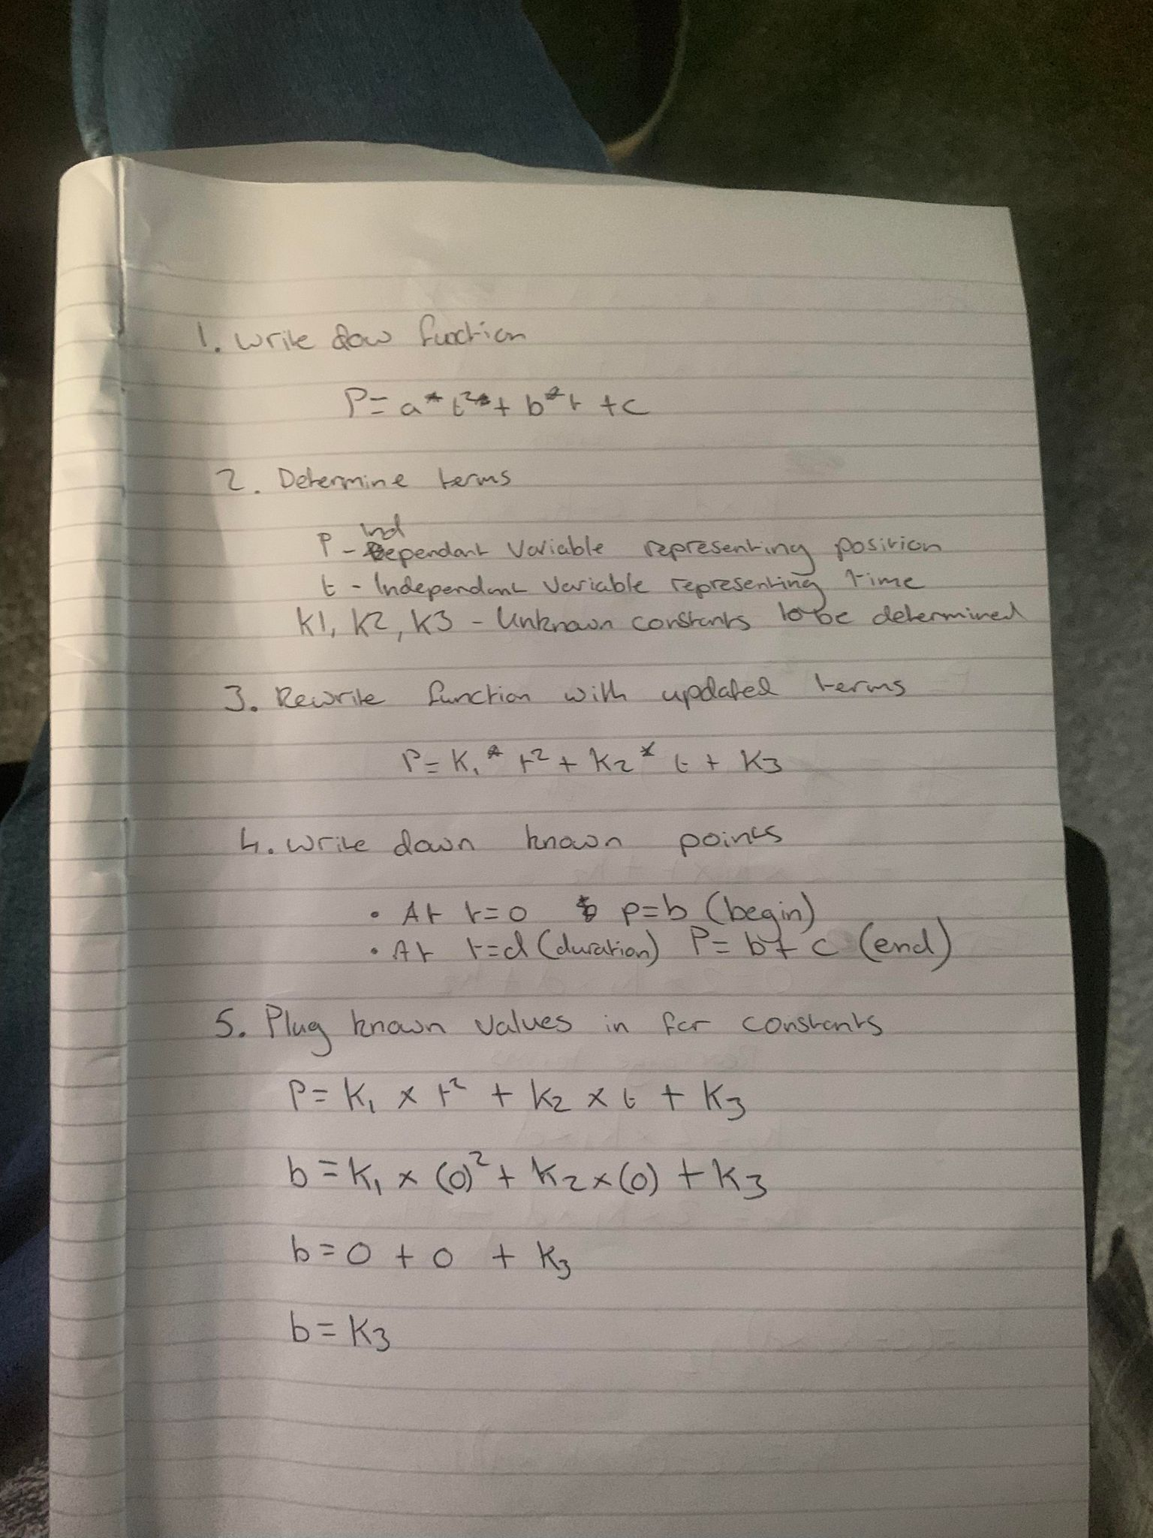

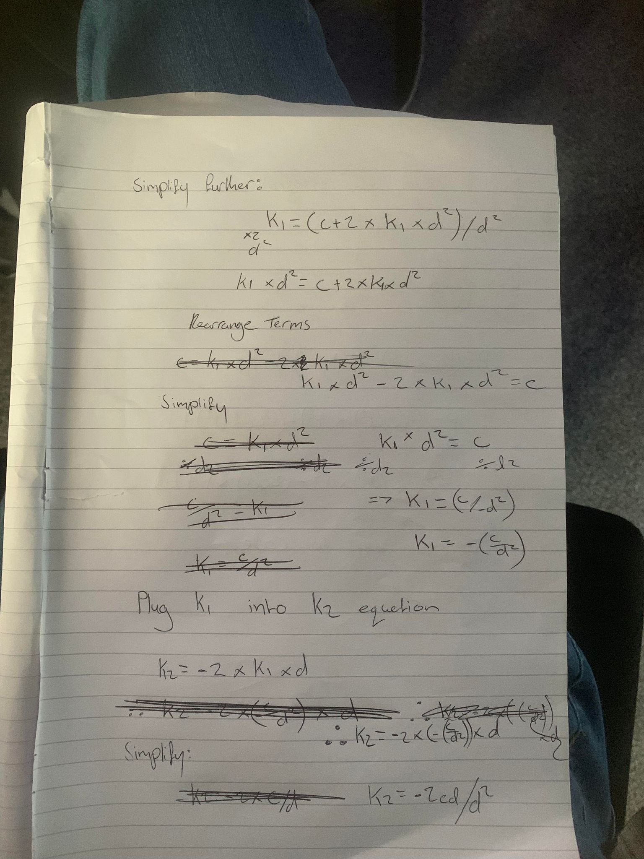

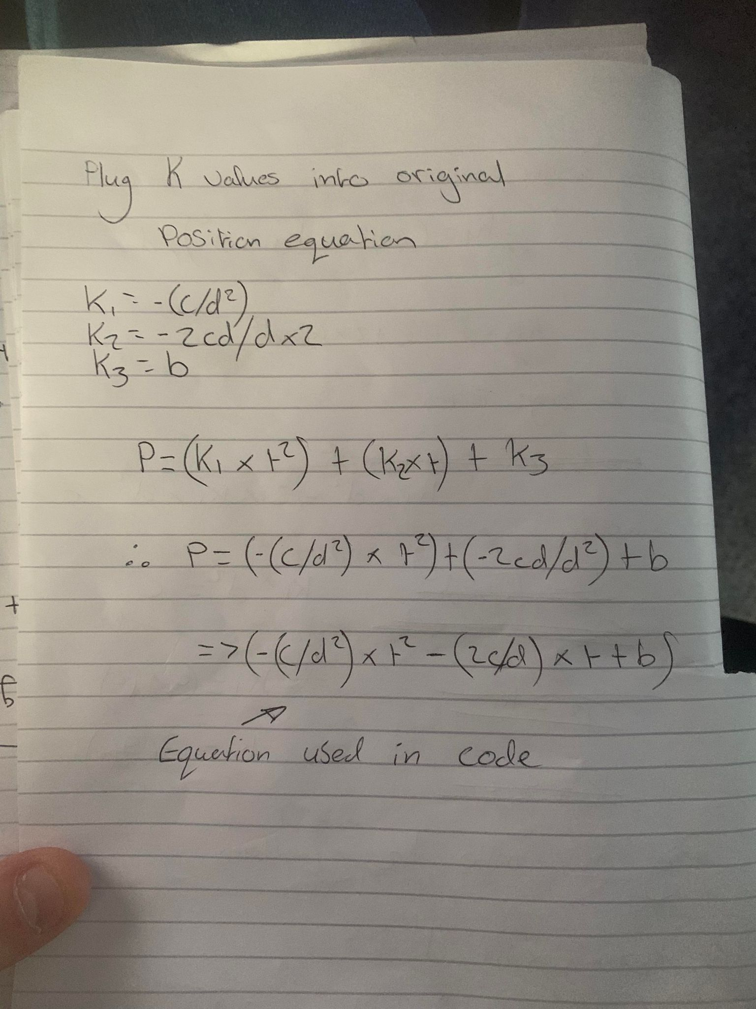

**Task 2:** Comparison with other potential easing functions

**Linear Easing**: Linear easing provides a constant rate of change between the starting and ending values. It has a simple equation that linearly interpolates between the values based on the current time.

sf::Vector2f EaseLinear(sf::Vector2f begin, sf::Vector2f change, float duration, float time)

{

float t = time / duration;

sf::Vector2f linearEase = (change * t) + begin;

return linearEase;

}

Linear easing produces a linear transition without any acceleration or deceleration. It might be suitable for scenarios where a constant rate of change is desired.

(Duim, *Easing functions for JavaScript - animation tool: Spicy Yoghurt*)

**EaseOutCubic**: Ease Out Cubic is another easing function that applies cubic easing to the values. It provides a more pronounced easing effect compared to quadratic easing.

sf::Vector2f EaseOutCubic(sf::Vector2f begin, sf::Vector2f change, float duration, float time)

{

float t = time / duration - 1.0f;

sf::Vector2f cubicEaseOut = (change * (t * t * t + 1.0f) + begin);

return cubicEaseOut;

}

The cubic easing equation used in this function gives a smoother and more gradual easing effect compared to quadratic easing. (Duim, *Easing functions for JavaScript - animation tool: Spicy Yoghurt*)

**Task 3:** Why is EaseOutQuad a good choice in this case?

The choice of an easing function depends on the desired animation effect and the specific application. However, EaseOutQuad can be a good choice for the following reasons:

* Smooth transition: EaseOutQuad provides a smooth and gradual easing effect. It starts quickly and slows down towards the end, creating a natural and visually pleasing animation. (Paullewis, *The basics of easing*)
* Simple implementation: The EaseOutQuad equation is relatively simple and easy to understand and implement. It requires basic arithmetic operations and does not involve complex calculations or external dependencies. (Duim, *Easing functions for JavaScript - animation tool: Spicy Yoghurt*)

**Sources**

Paullewis (no date) *The basics of easing*, *web.dev*. Available at: <https://web.dev/the-basics-of-easing/> (Accessed: June 2023).

Duim, C. (no date) *Easing functions for JavaScript - animation tool: Spicy Yoghurt*, *Easing Functions for JavaScript - Animation Tool | Spicy Yoghurt*. Available at: <https://spicyyoghurt.com/tools/easing-functions> (Accessed: 27 June 2023).